The 21st Century Education Revolution – an Education for Life

Placing the family at the heart of the holistic learning journey.

- Building authentic, effective and meaningful relationships

- Building caring communities

- Creating the most effective conditions for learning and the support of teachers, students and their families

©Robin Cox
CONTENTS
Page

Introduction 3

The Linear (Horizontal) System – an outdated model? 5

10 Principles of Vertical Tutoring 7

Key aspects of a Vertical Tutoring System 15

Horizontal (Linear) v Vertical Organizational Characteristics 16

How a Vertical Tutoring System best prepares young people for 21st Century
Lifelong Learning 17

How the Vertical Tutoring System redefines the collaborative role of the
Parents in their child’s holistic learning journey 18

Summary: Capturing the Vision of a 21st Century Vertical System School 20

Concluding Comments from the ‘Student Voice’ 21

Appendix One: How Maslow’s Hierarchy of Needs links with the Vertical
Tutoring System, based on the research of Peter Barnard 23
Introduction

The months of January to March 2017 – at which point I retired - will remain a significant highlight of my teaching career. During those months I was given a real-life snapshot of what an authentic holistic learning journey is all about. The experience was mind-blowing, exciting, exhilarating, transformational, a little messy, life-changing (from an education perspective) and much more.

I had spent four years at St Paul’s School in Brisbane, Australia, exploring different methods of ensuring the pastoral care of students and staff, searching for ways of uniting teaching and learning with pastoral care to create a single, holistic learning narrative fully understood and supported in partnership with all parents.

“The aim of holistic education must be to prepare students for a fulfilling and productive life in which their skills and attributes are constantly challenged, developed and applied as part of their lifelong learning. It is an educational journey of personal discovery starting within formal education then continuing through life.” (John Hare)

In the years preceding 2017 St Paul’s had trialled different programs, some more successful than others.

I had been reminded time and time again that quality teachers get to know their students before teaching their subject. Where this was being done professionally and effectively, there was noticeable progress confirmed by student evaluations of their experiences. Since the 1980s I had been researching and exploring various ways of supporting and encouraging young people to use and develop their many talents, to prepare them as people of influence in a fast-changing, increasingly global community. I had developed youth mentoring programs in New Zealand and Australia, as well as Peer Mentor and Peer Support Programs.

St Paul’s was undergoing some important structural and transformative changes, and I knew we had to start thinking laterally, especially as our school prided itself on creative and innovative thinking.

In 2015 I began communicating with Peter Barnard, a retired school principal and author from the United Kingdom. As we communicated and shared ideas and experiences, Peter helped me appreciate that no matter what new and potentially exciting programs the school introduced, there was one key area that was being ignored; the school did not have the best and most effective conditions for learning and the support of students and their families. It was the linear or horizontal system in use causing the challenges, not the students or the teachers.

It takes considerable guided reflection to look at one’s school with an open mind and consider the same-age organisational assumptions we take for granted. How could it possibly be that the disruption involved in reorganising the composition of tutor groups could make such a difference and solve so many of the problems that challenged us? Fortunately, Peter Barnard had not only successfully introduced Vertical Tutoring (VT) at his own schools but helped countless others do the same, running training programmes and workshops in schools around the world. He has also conducted necessary background research (www.verticaltutoring.org) and is regarded as the global expert in multi-age organisation (VT).

When Peter informed me that between 2007 and 2014 many hundreds of schools in the United Kingdom had transitioned to Vertical Tutoring, it was clear to me that there had to be something going on in these schools for that number of schools to make such a significant shift in their thinking.

On investigation, I sensed that these schools were looking to create an environment that guaranteed every child would be known and supported on their learning journey and that parents would be fully involved. School would be a place where learning relationships, alliances and support networks flourish; an education able to meet 21st Century demands and uncertainties.

A team of staff at St Paul’s was tasked with the job of exploring different approaches to pastoral care. I decided to focus on the Vertical Tutoring System and contacted schools in Australia and the United Kingdom to learn from their diverse experiences of Vertical Tutoring. At the same time, I researched adolescent neuroscience to explore ways that education groups and others were responding to the complex issues young people were facing on a daily basis - issues that included bullying, isolation, disengagement from school, deteriorating mental health and self-harm.

Having spent almost six months preparing the school community for changing from a ‘year’ (same-age) system to a multi-age tutor system, St Paul’s introduced the Vertical Tutoring System In January 2017. For the first time in my eight years at the school, I witnessed a whole school (P-12) come together in a way I had not previously seen, despite a 45 year career teaching in South Africa, New Zealand and Australia.

While the advantages of Vertical Tutoring are almost instant, implementation is ongoing. As Barnard says, ‘Manage the system and enable people (staff, students and parents) to take responsibility and leadership.’ Vertical Tutoring is a learning journey, one that requires constant systemic attention but much can be learned from other schools. The younger students thrive on being known and having great role models nearby every day until they too assume the mantle of leadership.

During those first three months in 2017, I witnessed, almost immediately, a calmer and happier atmosphere around the school, noticeably improving relationships between teaching and non-teaching staff, between teachers, students and parents, a decline in bullying and a friendlier more connected and supportive school environment as a result of the interactions between younger and older students. I had my first glimpse into what a Vertical System school ‘might’ look like in the ‘real’ world, one that has motivated and inspired me. Now that I have returned to New Zealand, it is important to share that experience with other educators, and those making decisions about the health and well-being of young people.

When a school commits to the key principles of a Vertical Tutoring System and wholeheartedly embraces all aspects of Vertical Tutoring, change is transformative, creating a collaborative culture between parents, students, and staff. Vertical Tutoring offers students a sense of connectedness and belonging that makes them more accomplished learners and better citizens, removing much of the risk from current schooling.

For Vertical Tutoring to be effective fundamental management principles are required that enable information to move freely between staff, parents and students. This needs all staff (school employees) including managers to commit to being tutors so that each form group has both a Tutor and Co-Tutor. The number of tutor groups increase in total but reduce in size (preferably a limit of 20 students per group). Another game-changer is an annual 45 minute Academic Tutorial or ‘deep learning conversation’ between the Tutor, parents and student to discuss the latter’s holistic education journey and develop ongoing ‘strategies for improvement’ to ensures the realisation of every student’s potential.

The positive focus on collaborative relationships and open alliances ensure that students, staff and families lead healthier and more balanced lifestyles with less anxiety and stress. VT is fully aligned with child psychology and child development socially and cognitively, a claim that same-age systems can only aspire to. It stands to reason that not only will there be fewer mental health and well-being issues affecting staff and student, but families too should function more effectively. Such changes should result in more positive and supportive schools and local communities, and the values such communities advocate and embrace will impact how a nation develops.

For multi-age organisations to succeed, schools (which includes all Board members) must ensure that all learning relationships are functional and interconnected enabling information to flow and support learning and interventions. This requires courage, fearlessness, teamwork and ongoing training of all involved as a new education narrative and distributed leadership evolves. Critically, leaders and managers must commit to such a system by being Tutors or Co-Tutors themselves.

When a school transitions to a multi-age system, governments can reduce the bureaucratic demands and regulations that too often impact negatively on schools. As the school moves from a teaching organisation to a learning organisation, the opportunity for teachers and non-teaching staff to develop authentic and meaningful relationships with students grows. There is much global research to suggest that young people cherish such diverse and close learning relationships during challenging and confusing adolescent years.
This paper, with the help, experiences and insights of Peter Barnard, tries to capture some of the critical aspects of a Vertical Tutoring School – a high trust organisation - and its increasingly powerful relevance in the 21st Century global community. This is merely a snapshot. I have not included the principled step-by-step guide to the implementation of a Vertical Thinking System in a school – a journey that will take between six and nine months – a process that requires considerable unlearning and new learning for all involved. Otherwise, no costs are involved!

The global community desperately needs paradigm change, one that not only places the idea of family life at the heart of the holistic learning journey but raises the status of teachers in the global community.

“Instead of preparing students for an unknown future, schools should see themselves as creating it.” (Peter Barnard)

Robin Cox October, 2018
With thanks to Peter Barnard

The Linear (Horizontal) System – an outdated Model?

“Schools were designed around the factory model which has been in place for over 130 years. Most United States of America [and elsewhere] schools are based on this model and focus too much on teaching for the test. Learners are unchallenged and unengaged by traditional models so they are searching for any alternative that they know: online courses, home schools, or maybe even dropping out. As a result, too many schools are closing and too many teachers are leaving the profession or being laid off.” (Barbara Bray)

Most of these schools will follow a Linear or Horizontal Thinking System.

- A student is faced with rebuilding relationships on entering a new school with adults, as well as connecting with and making new friends.

- Schools inadvertently might be placing a student in a linear (same age) Form or Tutor group on day one without thinking deeply about the consequences of this decision. This ‘might’ result in bullying, high anxiety, unnecessary stress and school disengagement. The student is ‘stuck’ with this group for his or her high school journey if the group continues to stay together.

- It will also take longer for the student to get to know the teacher.

- The student is possibly moving into an impersonalized environment, as it takes considerable time for the teacher to get to know each student; there are different teachers for different subjects; there might be a temporary teacher in place and any special support that’s needed will take time to set up.

“A same-age structure not only delays the formation of key learning relationships, but also stands full-square in the way of them, draining latent energy to exhaustion. It takes an age for social and learning relationships to form in the school if they ever do, increasing the need for compliance to ever expanding rules and specifications. Nothing works properly; nothing (like bullying [even cyberbullying] which itself is a manifestation of same-age structure) ever gets [effectively and meaningfully] resolved.” (Peter Barnard)

- Most linear schools begin the day with a Form Class or Tutor group with the sole purpose of taking the roll, possibly giving out some notices. Students who are late miss out on the Form or Tutor time and this might allow a few students to fall through the cracks, even become disengaged from the group and school before it is realized that these students might need some support.

- Some linear schools make a tentative positive step by introducing Vertical Tutoring, yet fail to understand the whole school approach, especially the strength of building that partnership with the students and their parents, as well as the power of the Tutor and Co-Tutor meeting with the students before the morning break.

- Parents wanting to sort out an issue with the school often have to leave a message at reception or with another administrative staff member, which might then be passed on to a Dean, for example. The Dean might be responsible for between 150 and 200 students in a Year group, highlighting the impersonalized nature of the learning relationship. This whole process, designed to allow the teacher to work with minimal interference, could cause delays, might result in mistakes, misunderstandings or frustrations occurring, thus causing unnecessary stress to a parent and their child.

- The student-teacher link might be beset with challenges and unreliabilities; the parent-teacher link might also be weak because of numbers of students the teacher has to work with.

- The linear system tries to help by adding the Form Tutor (maybe a House Tutor) and pro-social programs, but with limited success – same-age issues can multiply within the linear group.

- The linear system is a ‘one-size-fits-all’ system. It relies on students being separated by age and seeks to reduce complexity. The system starts painting a picture that looks something like this: failure to deliver what is needed creates a need for repeat work, more support staff, more managers, new fixes and information flow and slow interventions. This massively increases costs, slows work, damages morale and increases bureaucracy.

- From his personal experiences as a teacher, School Principal, researcher of best practices in education for over 25 years, author and Vertical Systems Thinking training expert, Peter Barnard suggests that the linear system displays all the hallmarks of the outdated ‘factory model’: a pre-defined curriculum, age-based, separated, linear, simplistic and ‘one-size-fits-all’. He believes that Vertical Tutoring is more able to engage with a complexity of people and demand while embracing the personalized holistic education experience for every student.

“Mixed-age structures enhance partnership and learning providing the binding glue that the same-age system takes for granted.” (Peter Barnard)

- Barnard suggests that a system, like a school, must have a purpose. However, if the school claims to be values driven but actually designs itself to be examinations or results driven (in reality), it creates a slew of contradictory behaviours that are rarely in the best interests of anyone.

“The limited measures (pass rates and levels) we use to judge school success determine the ‘de facto’ purpose but also the methods used by a school to achieve such a high purpose. The result of this powerful balancing loop is to perpetuate unfairness, maintain sameness and waste talent…. So much 21st Century school ‘reform’ is finding ways to get students through an ever-narrowing range of high stakes tests – isn’t that how schools are being measured?” (Peter Barnard)

- Many parents, with little or no understanding of education, especially the meaning of ‘holistic education’, are only interested in ‘results’, further negatively impacting the linear system.

“The same age model is simply too disconnected to have any bearing on a world driven by interconnectivity; its circulatory system is shot and this makes the school high risk and unsafe.” (Peter Barnard)

10 Principles of Vertical Tutoring Systems

Introduction: Understanding the Vertical Tutoring System

“What Vertical Tutoring does is to provide a new learning support operation that replaces the factory model and adds operational coherence. It builds value in and requires no social programs and no cost other than time to learn. It transforms the culture of schools by positively building inclusive, collaborative learning relationships and partnerships.” (Peter Barnard)

Vertical Tutoring is a cultural transformation of a school, a first big step towards a learning organisation rather than just a teaching organisation. It is the most meaningful and effective system to describe the holistic management of schools and the way good people (staff/parents/students), who populate and subscribe to our schools, go about their important work.

The world is changing, the world of work is changing, the world is getting smaller and the challenges greater; the world is less predictable; the signals are becoming stronger – things are speeding up – and knowledge is increasing at an exponential rate, as is technology.

A different mindset is required to meet these challenges.

“Leaders must be able to build organizations that are agile and can routinely innovate. People don’t want to follow a leader to the future – that is yesterday’s model. They want to co-create it.” (Linda A. Hill)

10 Principles of Vertical Tutoring Systems

Retired United Kingdom School Principal, Peter Barnard, has spent more than 25 years researching education issues, training school staff globally in preparation for the introduction of Vertical Tutoring Systems and developing the Vertical Thinking System.

Barnard has developed 10 Principles of Vertical Tutoring Systems which cover the three critical areas of customer care, in-group psychology, including its moral and spiritual base, and Systems Thinking. He has first-hand experience of the impact of Vertical Tutoring having introduced it at the two schools in the United Kingdom where he was a Principal.

- Enable and Build Learning Relationships

Vertical Tutoring ensures that all the partners or stakeholders (students, staff and parents) are involved directly in the student’s learning and play their positive and collaborative roles. The student is placed at the centre of a number of equally important learning relationships involving staff – both teaching and non-teaching staff - parents and peers. Vertical Tutoring ensures that students have time and support to be the learners and global citizens we need them to be and they need to be, and it captures and nurtures these affective and effective learning relationships. The school is an Information Market where customers rule and where everyone understands their role in the learning processes and each provides authentic services.

“I like how the barrier between younger and older students has been broken and we now have friends in older and younger years.” (Georgie, Year 9)

“A mixed-age tutor group is self-organizing, so it creates its own agenda based on need and context, an ideal place for learning support in all its guises.” (Peter Barnard)

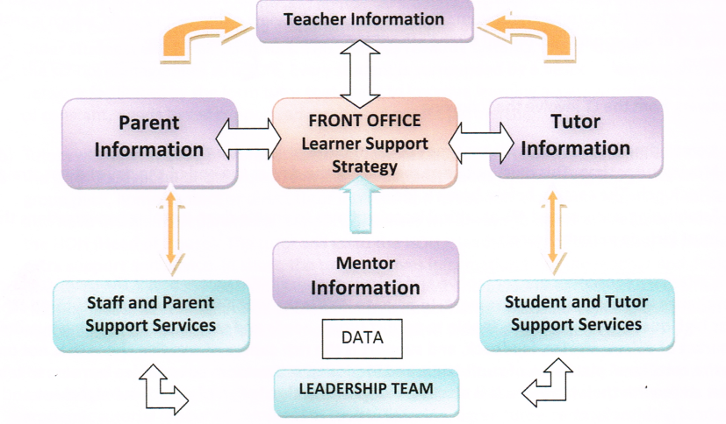

- Enable Creative Use of Data and Information

Vertical Tutoring demands good data and good information capture. It does this through enabling and developing meaningful, collaborative and positive relationships and the way the school organises itself. A Vertical Tutoring System builds these flexible and adaptive partnerships through annual Academic Tutorials (or Deep Learning Conversations) at critical times between the Tutor – and Co-Tutor where possible - parents and student. A story of the student’s life at the school is being created.

The school builds (designs) value in rather than adding value on. The Academic Tutorial uses data creatively to more effectively and better plan and support the learning process and the holistic learning journey. Parents and students have stories to tell and Vertical Tutoring ensures that time is invested in this important learning exercise to listen (manage variation). Information lights the way forward. In fact, this is the real heart of what ‘student voice’ should be. This process redefines what it is to truly care as an organisation - its spiritual good – and also gives authenticity to the meaning of ‘personalized learning’.

Creative Learning Strategist and educator, Barbara Bray, describes personalized learning as follows:

“Personalized learning means that learning starts with the learner. Learning is tailored to the individual needs of each learner instead of by age or grade level. It is more than teaching the same to everyone or “one size fits all” or even changing furniture. Personalized learning takes a holistic view of the individual, skill levels, interests, strengths and challenges, and prior knowledge. The learner understands how they learn and is motivated to own and drive their learning.”

What these relationships do is turn targets into strategies for improvement that are supported by all key players and monitored closely by the Tutor and Co-Tutor. While the Tutor will tend to be a teacher, the Co-Tutor is either a teacher or a member of the non-teaching staff keen to move alongside young people on their holistic education journey.

“There are many benefits and the most compelling one for me is genuine, real parental engagement which will mean that students and parents/carers have two key adults in the school who really know them and work together to achieve the best possible outcomes for every student.” (Rachel, Deputy Principal, 2015)

“It is not only numerical information that needs to flow around the school in an informal way but also emotional intelligence and support too. The school cannot just assume the psychology of child development, learning and well-being. It has to be designed-in, practised and personalized.” (Peter Barnard)

- Enable a Personal Curriculum

The discussion between the many voices involved in the learning process, including subject teachers, Tutors, Co-Tutors, students and parents, which should define and shape support, offer a more personalized learning experience and allow individual human potential - not only that of the student, but also of staff and parents - to develop. The many stories of the numerous journeys by so many students and their parents should be the main drivers of supported learning. Schools must listen to parental and student learning alongside a national learning and achievement framework. Vertical Tutoring is a simple organisational enabler of such a philosophy and springboard to a future of vertical teaching and learning. Meanwhile, we must cope with the present and use Vertical Tutoring to build meaningful, collaborative and positive relationships, community will and skills.

“Students’ academic performances improved because there was more of a ‘family’ environment, with relationships at the forefront of everything that’s going on. Students have a greater sense of belonging and are happier, thus taking a better attitude into the classroom. As years go by and Year 7 moves up the school, the Vertical Tutor System gets stronger and stronger.” (Sue, Deputy Head, 15 years’ experience of Vertical Tutoring, 2015)

- Enable improved learning and teaching

Parents, Tutors, Co-Tutors, other students and staff are all teachers and all have a responsibility for performance. However they can only be effective if the means of collaboration is in place. When the system of Vertical Tutoring is correctly established - based on and driven by values and principles - and all parties are playing their part, meaningful learning relationships are established that more effectively enable both teacher and learner as partners on the holistic education.

“The best thing about Vertical Tutoring is it provides both new and old students with a learning environment that is both friendly and effective.” (Jonathan, Year 10)

“The other day I had a really interesting talk with a Year 11 girl in my form in the lunch line. It made me realise that without Vertical Tutoring that would never have happened. (Alexandria, Year 8)

“I think that Vertical Tutoring makes different people more close, not only the students but the teachers too.” (Lydia, Year 7)

For a teacher to be successful requires all parties to play their part and this is what a Vertical Tutoring system enables. It unites all key players by establishing the importance of the Tutor and the Co-Tutor as the ‘front office’. It re-establishes the critical role of the Tutor (especially), parents and peers in the learning and support process. Students feel safe, cherished, valued and more equipped to engage in learning, while teaching is better facilitated, supported and more purposeful.

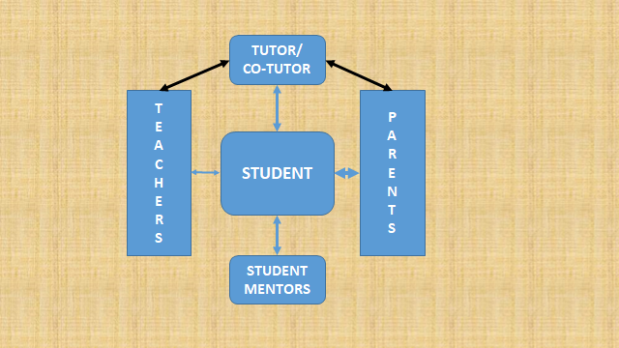

“[The School] has had vertical pastoral grouping for many years. Having come to [the School] from horizontally structured grouping schools, I would have to say the vertical outshines the horizontal in so many ways – the relational benefits, the sense of family, the ability to assist and mentor are all greatly enhanced in my view.” (Chris, School Principal, 2015)

- Enhance and Redefine Care

Vertical Tutoring ensures that the wider ‘village’ sees care holistically and especially in support for personalized learning to occur. A learning synergy is built by the Tutor - and Co-Tutor - and involves peers, parents and staff, whereby ‘deep care’ is implicit and designed-in. The Tutor and Co-Tutor are active advocates and informal mentors. Learning and care in a vertically tutored school go hand in hand. Care starts by reassigning in-group psychology to support and intervening as needed. Vertical Tutoring does this by building new supportive, collaborative learning relationships around every student. Only then does every child truly matter.

“Vertical Tutoring brings people together to talk and communicate. It also makes you get involved in a group. There are people from different years which means you can make new friends.” Ahmed, Year 10)

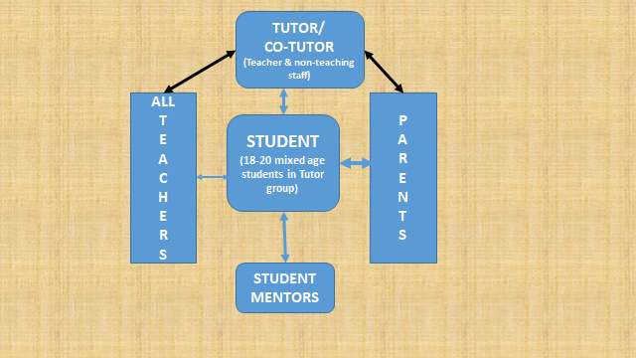

- Enable Leadership

Developing leaders or students with a positive influence in school is an essential activity. Leadership grows out of a servant mentality and an understanding of in-group moral psychology, almost by definition, and is best developed in the safety of mixed-age groups that some call family or whanau. Vertical groupings greatly enhance leadership opportunities and trust as core human values and are the most effective way to prepare 21st Century young people for life beyond school. All students, not the few, are given leadership, mentoring and guided opportunities to build confidence, raise self-esteem and become positive people of influence. This leads to greater empathy, resiliency, reciprocity, teamwork, humility, tolerance and respect for different cultures and attitudes, as well as those virtues that improve engagement with learning. Students are, therefore, enabled and equipped with the skills to become the global citizens that the community needs them to be and most would like to become.

“A shock at first, but now I wouldn’t have it any other way. One thing I really enjoy about Vertical Tutoring is having the older years in my form as I can ask them questions and discuss any worries I have about future years.” (Brooke, Year 10)

“I am a big fan of vertical grouping – but it works best where there is a definite and articulated philosophical basis to the groupings. I have found in the two schools where I have introduced it, that it has promoted student leadership and led to a more caring and compassionate student culture.” (Geoffrey, School Principal, 2015)

- Enable and Rethink ‘Voices’

Learning requires all voices to be heard. Parents need to be heard and engaged in the deep conversations that our complex and fast moving society so often ignores. Teachers need to be heard and peers also need to be heard, as all are critical to successful learning support and leadership. Vertical Tutoring nurtures and ensures such engagement by insisting on the organisational importance of learning conversations that both listen to these voices and enable the school as an organisation to respond. It is a virtuous circle. All voices are heard, though this can only happen when time is invested in people. From a simple conversation, we need to re-grow and re-nurture the student voice and this too transforms management. Each Vertical Tutor group is, potentially, a perfect School Council.

“It’s sooo scary at first because it is such a big change. But you get to do so much more. You get to have fun and make new friends whilst still staying close with your old ones. You will 100% enjoy it, without a doubt.” (Briony, Year 8)

“When students join and participate in mixed-age groups, their own horizons expand and for a time they are safe, protected from any negative peer pressure until they are ready to explore. By creating this place of security and attachment, resilience grows and this allows them to venture out with confidence rather than trepidation.” (Peter Barnard)

- Enhance the Academic Tutorial (Deep Learning Conversation)

At the heart of Vertical Tutoring is the Academic Tutorial or what some call the ‘Deep Learning Conversation.’ This is when the Tutor (the school front office) – and, where possible, the Co-Tutor - meets with parents and the Tutee (student) at a critical learning time, for 30 – 45 minutes each year, with all the relevant information (full School Report, information about the Tutee’s involvement or non-involvement in the holistic school life journey) present. This is an investment in people, unrestricted by bells and time constraints. It is the key that releases and enhances learning if done properly. The Academic Tutorial time has no time restraints in a truly Vertical System because the academic calendar spreads the engagement load over the year. It is this single act at a critical learning time (annually) that is the single most important conversation in the school year. It is deep, reflective, positive - and even spiritual - and very much life-enhancing, collaborative and learner friendly. In particular, the learning conversation makes sense of targets through a focus on strategies for improvement – which includes an understanding of living a healthy and balanced lifestyle - that enables personal targets set by the Tutee to be achieved. This information has to be captured, stored, monitored and referenced in School Reports. The Academic Tutorial gives credibility and meaning to two key areas of 21st Century lifelong learning: personalized learning and student self-empowerment.

“The school is driven by values not logistics. It personalizes learning relationships and so improves teaching and learning… The key is to manage the System so everyone can do the work needed to support and promote learning… Vertical Tutoring is entirely values driven and psychology secure … Everything improves over time when Managers manage the System rather than the people.” (Peter Barnard)

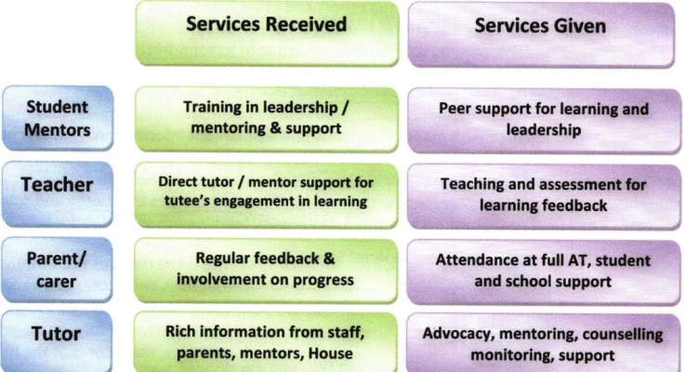
- AT= Academic Tutorial

- Enhance the idea of ‘Village and Family or Whanau’

For a student to be an important member of mixed-age groups of all sizes (where all are engaged in support, mentoring and leadership at various times) the learning environment has to be safe, secure and normal in an age when the family, in so many cases, is in crisis and under pressure. It is natural for older students to take the responsibilities and there is increasing neuroscience and education research showing the positive power and impact of peer to peer relationships. Vertical Tutoring encourages both the Tutor and the Co-Tutor to be facilitators of these positive peer relationships.

“As I am in Year 7 I don’t know any different and I really don’t have any worries about Vertical Tutoring. I like getting advice from the older years.” (William, Year 7)

Vertical Tutoring also allows the Tutor – and the Co-Tutor - to be a healer and to help families by supporting and encouraging them through the good and the tough times using the improved communication hotline Vertical Tutoring offers. Students are also members of Houses and the community beyond. In family (or whanau) type groups, the Tutors and Co-Tutors can facilitate a place for everyone. It is simply safer, more natural and more fun. All that is required is the knowledge of how to create this safe space. It is also more ‘educational’, more achievement orientated and more learner-friendly. The Tutor – assisted by the Co-Tutor - is head of the family (or whanau) in school and needs to be the person the students would prefer him or her to be. Vertical Tutoring is the real antidote to the gang, bullying, negative peer pressure – including cyber bullying - and other antisocial behaviours, as well as to rising levels of childhood anxiety.

“Once you go this route, you will not look back or return. The change is that good and beneficial for all involved.” (Tony, School Principal, 16 years’ experience of Vertical Tutoring, 2015)

“In a mixed-age environment, new students find themselves meeting people already empathetic toward them by design. The child does not have to vie for friendships but joins a network (family [whanau]) of fellow travellers all on different stages of their learning journey eager to help and empathize. This is not social engineering but simply a means of putting people in touch with who they were best meant to be, induction into a wider, safer, more supportive family-style network. In effect, the school fulfils the intrinsic needs of child development.” (Peter Barnard)

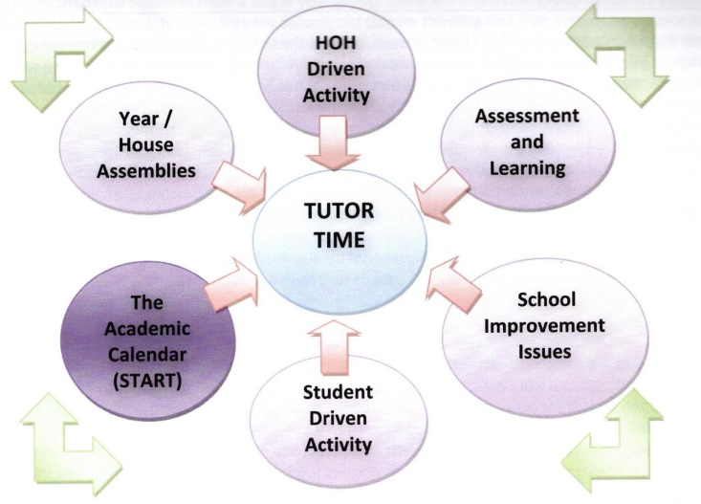
The Drivers of Tutor time in a Vertical Tutoring System

- Enable Complexity

Schools need to be complex not complicated to absorb value demand, and only people operating at the value edge can solve and innovate through complex challenges. Vertical Tutoring recognises the complexity of learning relationships as being creative, fun and full of change and rich in information. The skill is to use, and to make sense of such complexity and innovate, thus developing growth mindsets. Vertical Tutoring creates operational systems that welcome and thrive on the challenges of learning and innovation, enhances the entrepreneurial spirit of young people – providing the environment where they are comfortable to risk failure – thus preparing them effectively to play positive and meaningful roles as global citizens in their local and wider communities.

“I can attest to the significant impacts vertical tutoring had during my schooling life. The ability to interact and form relationships with people of all ages is fundamental in any work place. Vertical Tutoring provided a space to learn these skills whilst still at school. I can also say I have made some of my best friendships through VT – with people who I would’ve walked past without giving them a single thought prior to VT . ” (Rachel, University student)
Key aspects of a Vertical Tutoring System

- Students are organised into Houses.
- The House is run by a Head of House. The Head of House role is like that of a Principal of a school.
- Vertical Tutoring creates a nested system of schools (Tutor groups) within schools (Houses) within the School.
- Each Tutor group has two Tutors. The Lead Tutor is a teacher. The Co-Tutor might be a teacher or a non-teaching staff member. Extrapolated from over 100 School Prospectuses, the Tutor’s Position Description is a combination of the following:
  - to be the tutee’s mentor;
  - to be the tutee’s pastoral guide;
  - to be the tutee’s Academic guide;
  - to guide target setting processes with parents and tutee and use data and other information effectively in Academic Tutorials to improve outcomes;
  - to develop student Leadership and Citizenship;
  - to develop improved parental partnerships;
  - to be the student’s advocate.
- All members of the Senior Leadership Team are either Tutors or Co-Tutors.

“A preference here is for everybody in the school to become a tutor of a mixed-age group and, therefore, party to a value-adding subunit. When this occurs, leadership teams are able to learn firsthand what works, what needs tweaking, and what further support and training is necessary. It is a variation on servant leadership and embraces the idea that all change emanates from the points where value is added and complexity absorbed. This, and only this, brings distributed leadership into existence.” (Peter Barnard)

- There are between 18 and 20 students in each Tutor group – a maximum of four from any particular age/year/grade. Each Tutor group is balanced – age, gender, academic, co-curricular and social factors, including individual personalities and qualities across the Tutor group as a whole.
- One of the most important aspects of Vertical Tutoring is when the Year 13 students meet the Year 7 students for orientation activities the day before the rest of the school returns at the beginning of a new school year and the Tutor catches up with the parents of these new students either via a phone conversation or in a short 10 minute face to face welcoming conversation (maximum of four such conversations) on that same day.
- Tutor time is 20 – 25 minutes before the morning break and is not to be used for teaching programs. Tutors and Co-Tutors monitor, discuss, lead, plan and mentor, as do the students.
- The best times for reflecting on student learning (critical times) are identified and full Academic Tutorials (Deep Learning Conversations) are implemented. This will be one 30 – 45 minute conversation each year between the parents, child and Tutor at the end of which at least three strategies will be agreed on with regard to the ongoing development and holistic learning journey of the child.

“Parents are important because they have information to share and are a means of support and intervention that offers significant help in the learning process and, when this is added to the school’s contribution, learning improves. A working parent partnership is critical to the notion of a fully functional socially collaborative school as a viable systems model. … Parents, after all, are the first link with the world beyond the school gates and hold many useful insights into their child’s learning dispositions and emotional behaviour (and, most importantly, that of their friends!). In effect, they are a source of intelligence and a monitoring post, the external equivalent of the form tutor in the school.” (Peter Barnard)

- The school’s academic calendar is reconfigured to suit the Vertical Tutoring System Academic Tutorials.
- Student Reports contain strategies for improvement linked to collaborative decisions taken between parents, the student and the Tutor.
- Maslow’s Pyramid (Hierarchy of Needs) transforms into a model theory of learning for schools. Vertical Tutoring enables student input to be massively improved in practical, social and psychological terms (Appendix One).

Horizontal (Linear) v Vertical Organizational Characteristics

HORIZONTAL | VERTICAL
Same-age organizational base (linear) | Mixed-age organizational base (nonlinear/Vertical)
Values assumed (logistics driven) | Values-driven
Learning relationships slow to develop | Learning relationships formed immediately
Low mentoring opportunities | High mentoring/leadership opportunities; every child a mentor and mentee
Lower Order Tutor skills | Higher Order Tutor and Co-Tutor skills
Variable Student/Tutor Attention | Focused attention by need
Behaviour dominated | Collaboration/Learning dominated
Data sheet reporting | Reports rich in strategies for improvement
High Stress and High Control | Low Stress and Shared Control
Peer group pressure sometimes negative | Groups balanced by mixed-age, supportive
High potential for bullying/poor behaviour | Low potential for negative behaviour
Leadership opportunities for the few | Every child a leader
Year ethos difficulties | House ethos opportunities
Tutor isolated by Year | Tutor and Co-Tutor integrated by House; Tutor as the communications hub
Head of Year isolated by role | Head of House team runs the School (s)
High on rules, referrals, procedures, meetings | High on problem-solving at source (trust)
Leading from the top | Leading from the edge; servant leadership
No effective Academic Tutorial | Effective annual Academic Tutorial (Deep Learning Conversation)
Weak parental partnership; added on | Strong parental partnership designed in
Tutors and Tutoring often seen as low status staff | Tutors and Co-Tutors become high status, critically important staff
High need for add-ons and fixes and programs | Relevant programs designed in via networked relationships
Big Tutor Groups: few Tutors | Small Groups: Almost everyone a Tutor or Co-Tutor

How a Vertical Tutoring System best prepares young people for 21st Century Lifelong learning

“The core purpose of education is to prepare young people for life after school; helping them to build up the mental, emotional, social and strategic resources to enjoy challenges and cope well with uncertainty and anxiety.” (Sir Ken Robinson)

The Vertical Tutoring System gives young people in mixed-age groups the opportunity to develop into competent, caring, empathetic, motivated and responsible global citizens as they develop key lifelong learning skills within a safe and secure environment.

The Vertical Tutoring System creates the best conditions for the students’ learning and support, as they will be able to explore ideas, ask questions and share thoughts and opinions under the watchful eye of ‘the wise guides on the side’ (the Tutor and Co-Tutor) who will facilitate and manage the interactions between all team members. Skills learned in the classroom can be refined, honed and developed in the Tutor group and vice versa.

The Vertical Tutoring System gives schools the flexibility to develop creative opportunities for the Tutor group to meet, for example, once a week for a Tutor period during which time older students can assist younger students with study, discuss school issues and help the younger student with daily responsibilities such as the effective management of time, how to use a Diary and how to organize and plan their schedules. This is in addition to the 20 to 25 minute daily Tutor gathering before the morning break, a non-negotiable key aspect of an effective Vertical Tutoring System.

Some of the key skills required in the 21st Century workplace, according to global and neuroscience research, which will be designed-in, developed, refined, sharpened and fine-tuned in a non-threatening, encouraging and supportive mixed-age Tutor group, as a result of the variety of opportunities and activities students will experience might include:
- Learning how to think critically and creatively.
- Learning the importance of collaborating as a team player. This will include discovering the strengths and capabilities of all members of the Tutor group and working together to utilize these unique gifts and talents in positive ways. This will lead not only to pro-social behaviour, but will also enhance the development of high self-esteem and stimulate, as well as motivate students to embark on positive goal-getting journeys.
- Learning effective communication skills – both verbal and written – which can be utilized on different occasions and in a variety of circumstances. There will be opportunities for students to develop key analytical thinking skills as they learn how to access information and then develop reasoned arguments embracing critical thinking and problem-solving skills. The mixed-ages will enhance these communication skills through the encouragement of listening respectfully to every ‘student voice’, displaying important relationship qualities like empathy, tolerance, compassion, care, sensitivity and a sense of humour.
- Learning how to adapt their ideas or thinking as they engage constructively with team members. These experiences will assist them to become reliable, responsible and more trustworthy global citizens.
- Learning, often through the development of House activities, for example, the capacity for creativity, design-thinking and critical thinking; looking at all aspects through the different perspectives of the individual team members and appreciating the power of co-creating new ideas and solutions to challenges.
- Learning how to become entrepreneurial and innovative, willing to take calculated risks as curiosity and imagination is encouraged. This might involve networking with other Tutor groups or stakeholders, understanding the meaning of ‘strategic thinking’, sometimes learning that there is often no one right answer.
- Learning how to reflect and evaluate both from a personal and a team perspective.
- Learning the importance of taking ownership of the decisions they take and the choices they make both as individuals and as team members – self-empowerment.
- Learning by doing – an experiential journey – which can enhance intrinsic motivation.

The Vertical Tutoring System will encourage new mindsets. Tutors and Co-Tutors, guided by the Head of House, will create the necessary structure and supportive environment that allows students to develop these key 21st Century life skills, while also keeping the element of fun at all times.

Staff will provoke the students’ new thinking while appreciating that innovation is likely to be messy, disruptive, non-compliant and chaotic in these multidisciplinary teams.

The most effective and meaningful Tutor groups will become inspiring and motivating hubs of learning for all team members (staff included).

How the Vertical Tutoring System redefines the collaborative role of the parents in their child’s holistic learning journey

“Parents know children best and, therefore, have a critical role in helping the school evolve a more rounded understanding of their child’s unique qualities and capabilities.” (Sir Ken Robinson)

The Vertical Tutoring System – with the collaborative partnership between parents, child, Tutor and Co-Tutor – is a positive and holistic response to the needs of most parents, some of which include the following:

- someone to be there for the child;
- someone to talk to;
- someone who is authentic, has a great sense of humour and understands the importance of teaching the child their subject (in that order);
- someone who will listen to their learning story;
- someone who knows their child well;
- someone who recognises their “whole child” and their child’s potential;
- someone who will speak to the child’s potential which the child might not be seeing for a variety of reasons;
- someone who will speak for the child and support his/her learning;
- someone who values parents and supports the family (or whanau);
- someone capable of recreating the family (or whanau) in the school;
- someone who will always be there and keep in touch as needed;
- as the child progresses up the school, they want someone they know well to tell them how their child is doing and how, as parents, they can still be involved and valued, how they can help in difficult times, be better at what they do and have someone to tell them that they are really doing a great job. Systems thinkers call this ‘customer services’.

This collaborative partnership will best prepare young people for lifelong learning and will assist parents to understand the critical role they play in moving alongside their child, most especially during the confusing and challenging adolescent years when the brain is at a critical stage of development.

Many parents also need to appreciate and understand that young people today are likely to have different aspirations and dreams from their parents. This is largely due to the Digital Age in which they are growing up and the pace of technological advancement and discoveries.

Young people, generally, have a deep desire to connect with others, enjoy collaborating and think more on a global scale. However, what they require is sensitive and caring nurturing on how to discover and listen to their deeper inner voice, as well as the power and importance of reflection if they wish to develop their true selves.

The child will hear consistent, supportive and caring messages of hope, receive guidance on how best to live a healthy and balanced lifestyle and will be well prepared for the real world journey beyond school. Parents, in turn, will be encouraged by the Tutor and the Co-Tutor:

- to understand how their child is unique, with their own interests, aspirations, gifts, talents and temperament;
- to focus on their learning and appreciate that it is okay to fail while moving out of their comfort zone and trying something new or different;
- to trust and encourage their child to explore their interests, discover their passion and chase their personal dreams;
- to talk about school, its relevance in preparing their child for lifelong learning and the importance of a well-rounded education journey through becoming involved in co-curricular or out of school programs, while still having the important free time for socializing, relaxing and having fun;
- to affirm the efforts of their child rather than having a skewed focus on ‘results’;
- to work collaboratively with all stakeholders to guide the child’s planning for life beyond school;
- to look for, name and encourage their child’s strengths and how best to utilize these strengths for lifelong learning;
- to understand how to develop intrinsic motivation within their child that will allow him or her to develop self-confidence, be prepared to take risks and be assertive, while remaining humble, empathetic, tolerant of other cultures and ideas and appreciating the importance of teamwork in the 21st Century global community and workplace;
- to explore ways in which they can enrich their child’s holistic learning journey through sharing their own stories, networks and interests while role-modelling and communicating clear values which should also be aligned with the values of the school;
- to encourage the “What if?” thinking, as this process of inquiry might spark the creative and innovative thinking of their child, so important for the 21st Century world of work;
- to guide their child on how to be responsible with the use of finances (economically responsible), become an independent thinker able to ignore negative peer pressure and develop the fearlessness required to develop an idea into a possible entrepreneurial venture;
- to work positively through conflict situations, as they appreciate that many 21st Century work opportunities will involve the sharing of ideas with a collaborative spirit. This will involve being able to disagree with others respectfully, while remaining loyal and enriching the positive learning and creative environment in which they might be working;
- to appreciate that, while academic content is important, the key is how to apply that content or knowledge in new situations or challenges in the 21st Century world of work;
- to understand how important it is to give their child a ‘voice’ to express their thoughts, feelings, aspirations, opinions and ideas respectfully, yet without being judged;
- to be co-creators with their child of the latter’s entrepreneurial thinking and ideas to make a positive difference within the local and global community.

Summary: Capturing the Vision of a 21st Century Vertical System School

- Schools are organised in a nested Vertical Tutoring System (schools within schools) which sets in motion positive changes to all the key learning relationships between parents, school and students.

The nested Vertical Tutoring System is designed to connect people to each other – parents to schools, children to learning, older students to younger students, all students to all staff members (teaching and non-teaching).

The school personalizes relationships between the parent, the student and the student’s Tutor (a teacher) and Co-Tutor (a teacher or non-teaching staff member) and secures learning relationships and processes to ensure that every child is known and supported and no child is left behind.

Communication flow within these partnerships is strong and consistent, useful information sharing increases, intervention is rapid and support for learning easily accessible.

Morale (well-being or mindfulness) improves because ALL members of the school community enjoy and value their collaborative working environment. Instead of adding mindfulness on, for example, a mindful school is created where empathy is designed in and everybody is a mentor.

- There is an effective Staff Senior Leadership team structure that is focused on learning and teaching and is Values driven – ALL learning relationships flow and support the process of developing the whole child.

- The school’s capacity for building supportive learning relationships and pro-learning groups is increased.

- Students are linked to Houses within the school, which instil values aligned with the School’s Vision and Mission Statements.

- Within the House, the students are members of small Tutor groups (whanau) and care, nurture and mentor each other while developing their unique gifts and strengths (resilience).

- Students remain with the same Tutor group all the way through High School, so they develop positive relationships with their Tutor and Co-Tutor and gain a deeper understanding of the meaning of ‘in-group loyalty’.

- Students, parents and staff work collaboratively within an environment that promotes and develops lifelong learning skills built on the strong foundations of the 3Rs (Reading, Writing and Numeracy).
- This collaborative partnership flows into a higher quality of learning within the classroom, thus leading to improved academic performances; schools develop better learning dispositions and attitudes that are critical to increasing learning intelligence.

- Students become confident team members in a happier, innovative, creative, self-empowering learning environment which promotes and understands the importance of all community members living healthy and balanced lifestyles while leading lives of purpose.

- Students feel valued, their opinions and thoughts listened to, encouraged and supported by empathetic school staff – most especially their Tutor and Co-Tutor.

- These students are learning in an environment which truly reflects the society they live in and prepares them for the real world of work.

- Students develop the self-confidence to connect, interact and positively engage with other students of different ages and cultures in this safe and secure environment.

- Students are encouraged and supported to take responsibility and develop leadership roles and an entrepreneurial spirit. All students have opportunities to develop as facilitators, mentors, co-tutors and people able to positively influence their school community.

- These students are positive role models for each other and take responsibility, with support from their Tutor and Co-Tutor, for removing negative and antisocial behaviours from their school community. The new mentoring and in-group loyalty structure, designed into the system, reduces the chances of bullying in any form.

- Students develop selflessness, which encourages them to give willingly of themselves in service to others within their local and global communities expecting nothing in return.

“As I see it, the aims of education are to enable students to understand the world around them and the talents within them so that they can become fulfilled individuals and active, compassionate citizens.” (Sir Ken Robinson)

Concluding comments from the ‘Student Voice’

Speaking at her School end of year Celebration of Achievement (Speech Day), School Captain, Rachel Munt, reflecting on her final year at St Paul’s School in Brisbane, Australia, which had implemented Vertical Tutoring in January 2017, stated:

“2017 has been one of the most exciting, transformative and pivotal years in the school’s history, with significant changes to the house system taking effect. The house system has always been an integral part of our school’s culture, but now, more so than ever. With students now connecting with peers from all year levels, the potential to learn from, and form invaluable connections has been established. At the beginning of term 1 this year, we knew we had a huge task ahead of us. How do we maintain the house culture whilst fully immersing ourselves into the vertical system? Whilst it was of course a delicate balance, I can confidently say that, through the persistence, dedication and open mindedness of staff, students, parents and alumni, the vertical system is now in full swing, and we are seeing the resulting benefits in numerous areas.

The annual inter-house carnivals have been crucial to the success and cohesion of the new houses this year. It was truly amazing to see how well the houses had come together in such a short amount of time to compete at the annual swimming carnival in term 1. As students began to get to know those in their tutor groups and houses, we saw how, with vertical tutoring, we really are ‘All in this Together.’ Possibly the most exciting change to carnivals this year, was the inclusion of the junior school, which had previously held a separate carnival. The younger students brought a whole new energy to the events, and encouraged the senior school to adopt the same level of both energy and school spirit. Athletics day was a further testament to this, as the junior school joined us for our final relays of the day. The competitiveness and pride exhibited was something we had never seen before, and was something that the senior students will always remember.”

Appendix One: How Maslow’s Hierarchy of Needs links with the Vertical Tutoring System, based on the research of Peter Barnard:

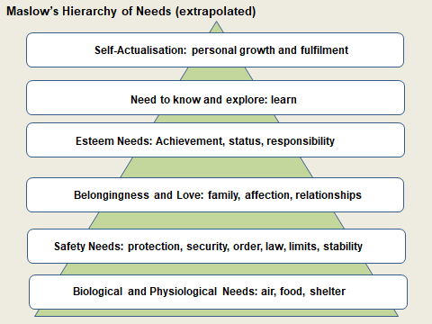

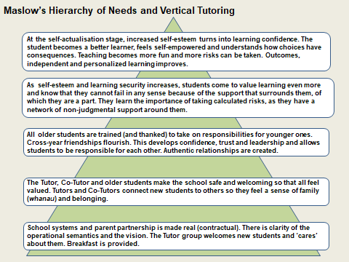

Hare J. Holistic Education: An Interpretation for teachers in the IB programmes, International Baccalaureate Organization, 2010.
Sourced from: http://barbarabray.net
Socially Collaborative Schools: The Heretic’s Guide to Mixed-Age Tutor Groups, Systems Design, and the Goal of Goodness, Peter A. Barnard, Rowman & Littlefield, 2018.
Linda A. Hill, Professor of Business Administration, Harvard Business School, DAVOS, 2017.
Source: (adapted) An Edited Version of The Key Themes and Inherent Principles of Vertical Tutoring by Peter Barnard, April 2016.
All diagrams from: Vertical Tutoring – notes on school management learning relationships and school improvement; Peter A Barnard; Grosvenor House Publishing Limited, 2010; https://www.verticaltutoring.org and from training workshops run by Peter Barnard in 2016. Other quotes from Peter Barnard resources – and personal correspondence - some of which are highlighted. Used with permission.
Socially Collaborative Schools: The Heretic’s Guide to Mixed-Age Tutor Groups, Systems Design, and the Goal of Goodness, Peter A. Barnard, Rowman & Littlefield, 2018.
Sourced from: http://barbarabray.net
Used with permission: St Paul’s School Pastoral Care Structure Review, April 2016.
Used with permission: St Paul’s School Pastoral Care Structure Review, April 2016.
Used with permission: St Paul’s School Pastoral Care Structure Review, April 2016.
Whanau - A New Zealand Maori word - an extended family or community of related families who live together in the same area. For more information: https://teara.govt.nz/en/whanau-maori-and-family/page-1
Used with permission: St Paul’s School Pastoral Care Structure Review, April 2016.
Socially Collaborative Schools: The Heretic’s Guide to Mixed-Age Tutor Groups, Systems Design, and the Goal of Goodness, Peter A. Barnard, Rowman & Littlefield, 2018.
Used with permission: St Paul’s School Pastoral Care Structure Review, April 2016.
Socially Collaborative Schools: The Heretic’s Guide to Mixed-Age Tutor Groups, Systems Design, and the Goal of Goodness, Peter A. Barnard, Rowman & Littlefield, 2018.
Socially Collaborative Schools: The Heretic’s Guide to Mixed-Age Tutor Groups, Systems Design, and the Goal of Goodness, Peter A. Barnard, Rowman & Littlefield, 2018.
Socially Collaborative Schools: The Heretic’s Guide to Mixed-Age Tutor Groups, Systems Design, and the Goal of Goodness, Peter A. Barnard, Rowman & Littlefield, 2018.
Robinson K. and Aronica L., Creative Schools – Revolutionary Education from the Ground Up. Penguin, 2016.
Robinson K. and Aronica L., Creative Schools – Revolutionary Education from the Ground Up. Penguin, 2016.
Wagner T. Creative Innovators. The Making of Young People Who Will Change The World. Scribner, 2012.
Robinson K. and Aronica L., Creative Schools – Revolutionary Education from the Ground Up. Penguin, 2016.
Used with permission: Celebration of Achievement Address, Rachel Munt, October 2017

